# //            Q1.   WAP TO INPUT TWO NUMBERS AND COMPUTE ALL // ARITHMETIC OPERATIONS

#include<stdio.h>

int main(){

  printf("This Program is made by Ashish Madhup \n");

int a,b;

  nt sum,diff,multi,mod;

    float div;

    printf("Enter a and b ");

    scanf("%d%d",&a,&b);

    sum= a+b;

    diff= a-b;

    div= a/b;

    multi=a*b;

    mod= a%b;

    printf("sum is %d \n" ,sum);

    printf("diff is %d \n",diff);

    printf("div is %f \n",div);

    printf("multi is %d \n",multi);

    printf("mod is %d \n",mod);

return 0;

}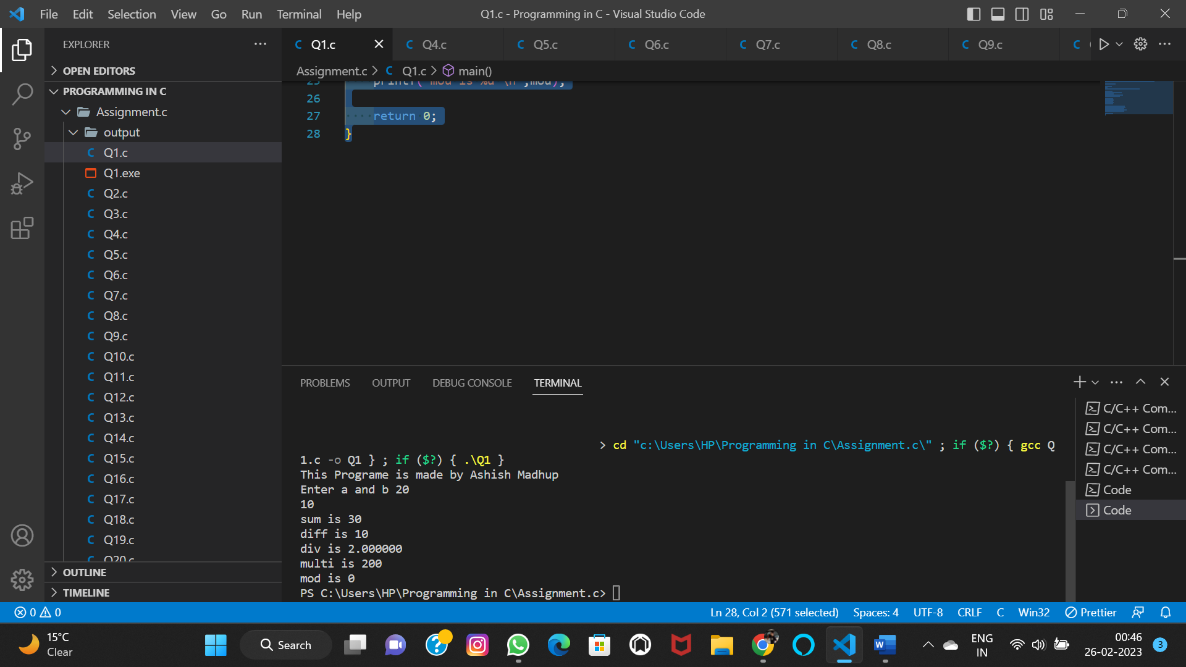

# //            Q2.  WAP TO FIND SIMPLE INTEREST.

#include<stdio.h>

int main(){

    printf("This Program is made by Ashish Madhup \n");

    int p,t;

    float r;

    int si;

    printf("enter:\n Principle Amount \n Time \n Rate\n");

    scanf("%d%d%f",&p,&t,&r);

    printf("the principal Amount is %d is fixed for %d year at %f percent\n",p,t,r);

    si=p*r*t/100;

    printf("The simple intrest is : %d\n",si);

    return 0;

}

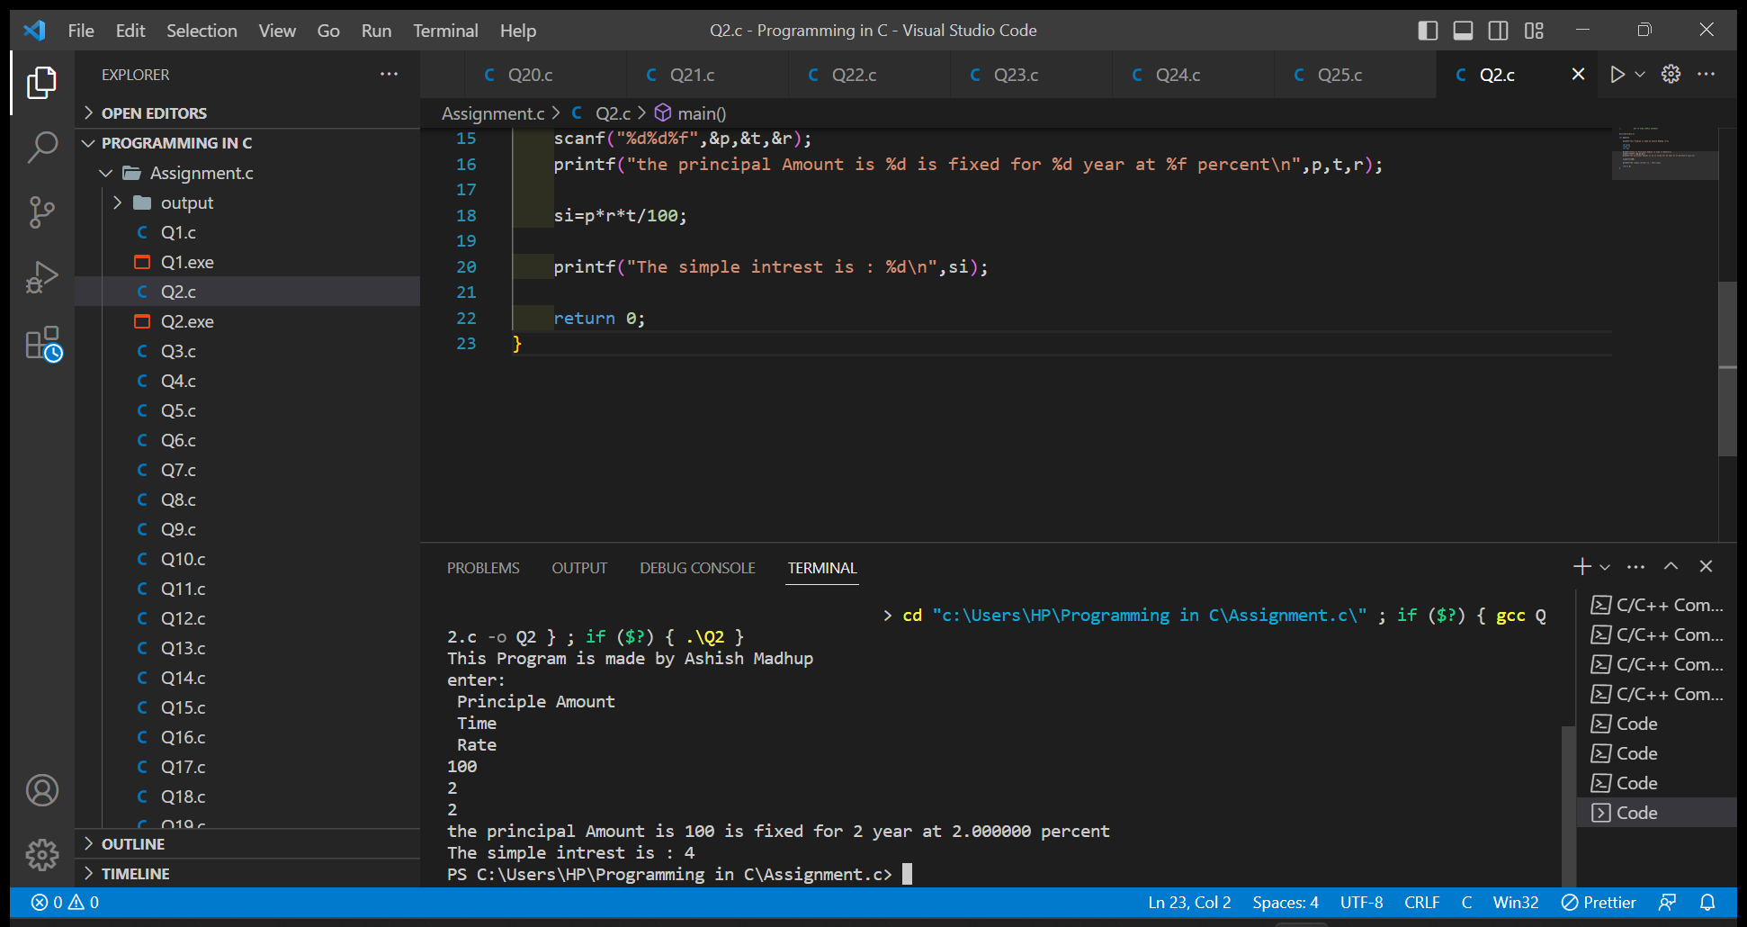

# //        Q3.          WAP TO FIND THE SUM, AVERAGE AND PERCENTAGE // OF MARKS OBTAINED IN FIVE SUBJECTS.

#include<stdio.h>

int main(){

    printf("This Program is made by Ashish Madhup \n");

    int m1,m2,m3,m4,m5;

    int totalmarks;

    float ave;

    printf("enter your marks \n Maths : \n Chemistry : \n Physics  : \n English : \n Social Science : \n");

    scanf("%d%d%d%d%d",&m1,&m2,&m3,&m4,&m5);

    totalmarks=m1+m2+m3+m4+m5;

    printf("Total Marks is : %d" ,totalmarks);

    ave= totalmarks/5;

    printf("The Average is  : %f",ave);

if(ave>90)

printf("Grade is A");

else if(90>ave>80)

printf("Grade is B");

else if(80>ave>70)

printf("Grade is C");

else if(70>ave>60)

printf("Grade is D");

else

printf("Not Eligible For Grade");

    return 0;

}

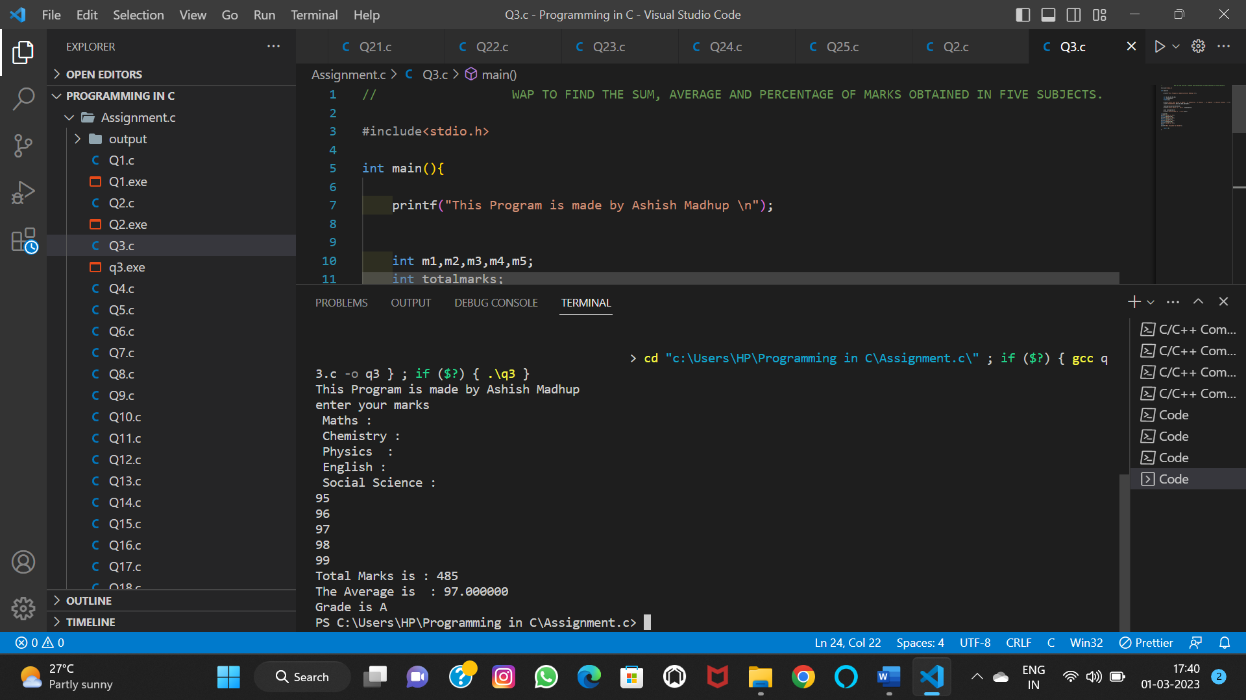

# //    Q4.  WAP TO ACCEPT ROLL NUMBERS AND MARKS OF THREE // SUBJECTS FROM USER AND  PRINT TOTAL MARKS,

# // AVERAGE AND GRADE.

#include<stdio.h>

int main(){

    printf("This Program is made by Ashish Madhup \n");

    int m1,m2,m3,roll_number,total_marks;

    float ave;

    printf(" Enter Your Roll Number :  ");

    scanf("%d",&roll_number);

    printf("Enter Marks of Subject 1 :  ");

    scanf("%d",&m1);

    printf("Enter Marks of Subject 2 :  ");

    scanf("%d",&m2);

    printf("Enter Marks of Subject 3 :  ");

    scanf("%d",&m3);

    total_marks=m1+m2+m3;

    ave=(total_marks)/3;

    printf("Total Marks is : %d\n",total_marks);

    printf("Your Average is  : %f\n",ave);

    if (ave>90)

    {

    printf("Your Grade is A\n");

    }

    else if ((ave<90)&&(ave>80))

    {

        printf("Your Grade is B\n");

        }

    else if ((ave<80)&&(ave>70))

    {

        printf("Your Grade is C\n");

        }

    else if ((ave<70)&&(ave>60))

    {

    printf("Your Grade is D\n");

    }

    else

    {

        printf("Your Grade is E\n");

        }

        return 0;

}

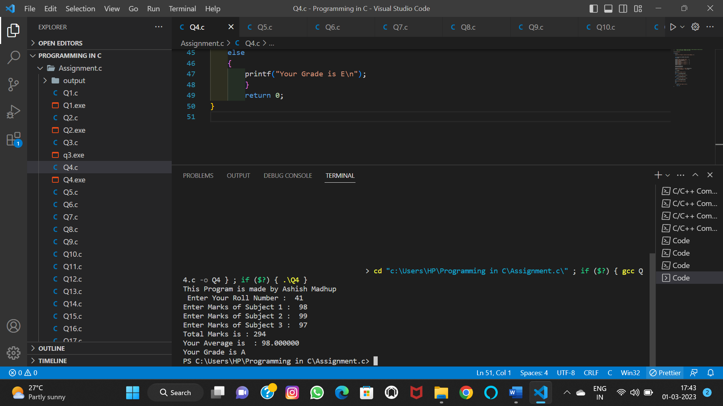

# //   Q5.   WAP TO SWAP TWO NUMBERS WITHOUT USING THIRD VARIABLE

#include<stdio.h>

int main(){

    printf("This Program is made by Ashish Madhup \n");

    int a,b;

    printf("Enter a & b : ");

    scanf("%d%d",&a,&b);

    a=a+b;

    b=a-b;

    a=a-b;

    printf("The Value of a & b after swaping is %d & %d",a,b);

    return 0;

}

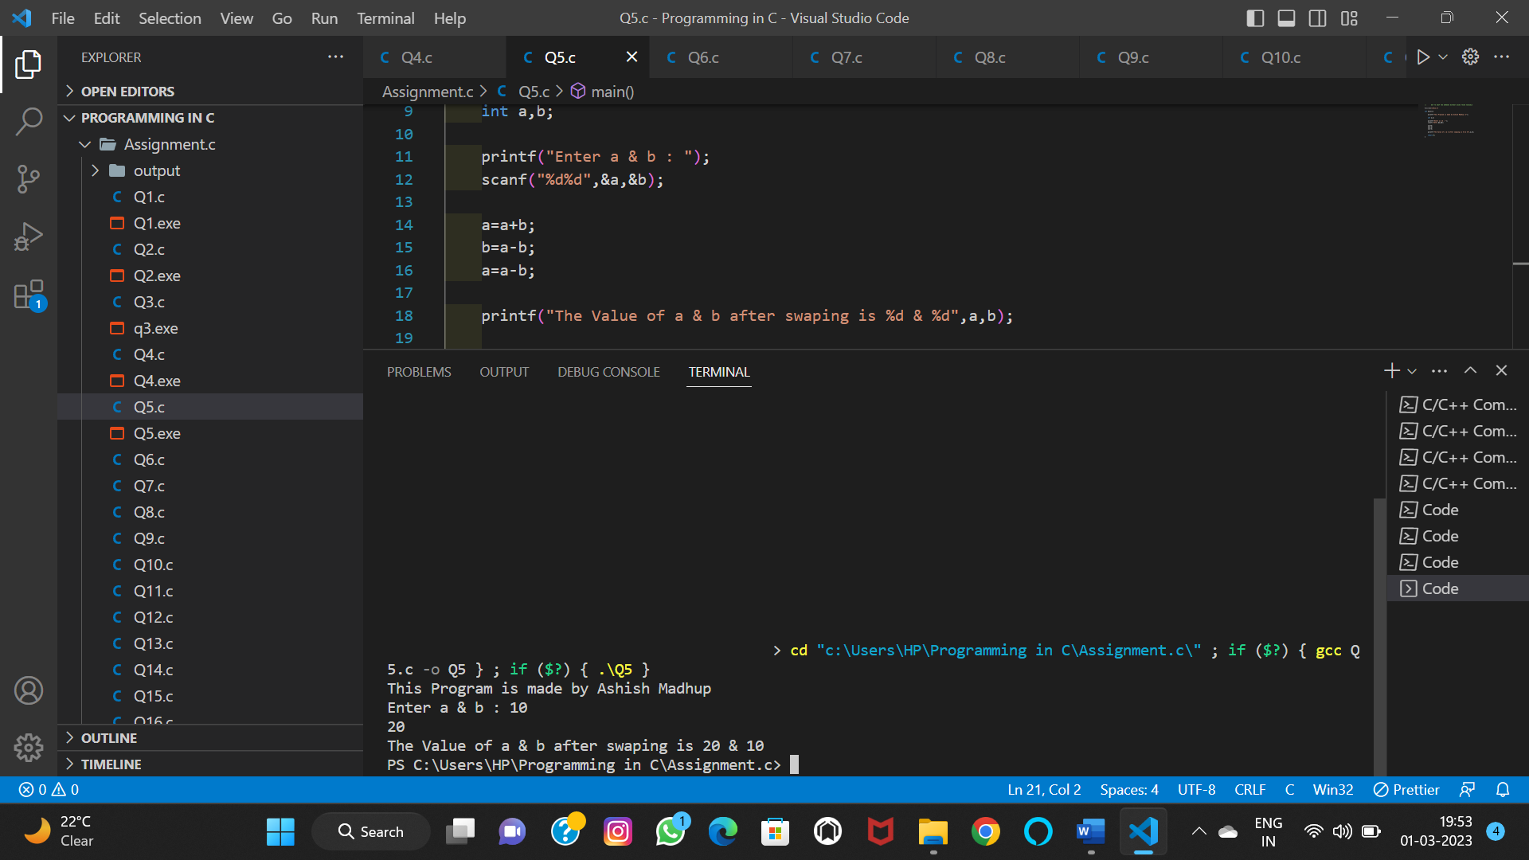

# //   Q6.   WAP TO SWAP TWO NUMBERS USING THIRD VARIABLE.

#include<stdio.h>

int main(){

    printf("This Program is made by Ashish Madhup \n");

    int a,b,c;

    printf("Enter A : ");

    scanf("%d",&a);

    printf("Enter B : ");

    scanf("%d",&b);

    c=a;

    a=b;

    b=c;

    printf("Enter Value of A after swaping : %d\n",a);

    printf("Enter Value of B after swaping : %d\n",b);

return 0;

}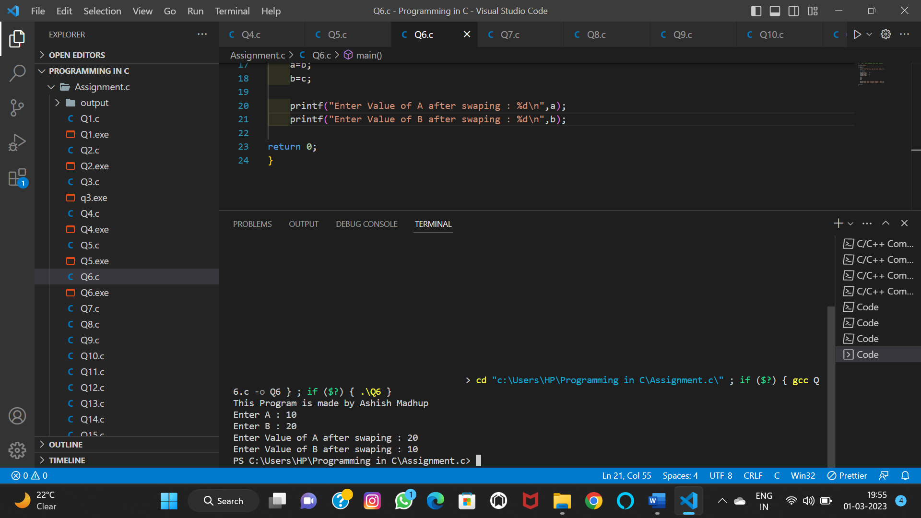

# //   Q7. WAP OF A CALCULATOR USING A SWITCH CASE.

   #include<stdio.h>

int main()

{

    printf("This Program is made by Ashish Madhup \n");

    int a, b;

    char choice;

    printf("Enter your choice\n");

    printf("a. Addition\nb. Subtraction\nc. Multiplication\nd. Division\n");

    scanf("%c", &choice);

   printf("Enter 2 integer numbers\n");

   scanf("%d %d", &a, &b);

    switch(choice)

    {

        case 'a': printf("%d + %d = %d\n", a, b, (a+b));

                break;

        case 'b': printf("%d - %d = %d\n", a, b, (a-b));

                break;

        case 'c': printf("%d x %d = %d\n", a, b, (a*b));

                break;

        case 'd': if( b != 0)

                    printf("%d / %d = %d\n", a, b, (a/b));

                else

                    printf("Number can't be divided by 0\n");

                break;

        default: printf("You entered wrong choice\n");

                 break;

    }

    return 0;

}

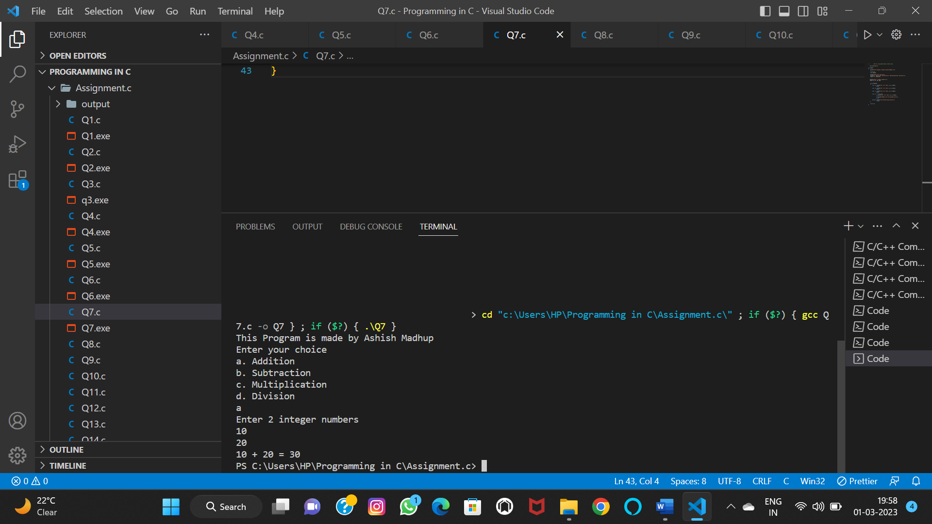

# //       Q8.   WAP TO FIND THE FACTORIAL OF THE NUMBER ACCEPTED // BY THE USER.

#include<stdio.h>

int main(){

    printf("This Program is made by Ashish Madhup \n");

    int n ,fact=1;

    printf("Enter Your Number : ");

    scanf("%d",&n);

    if(n<0)

    {

        printf("Factorial is not possible");

    }

    else if (n==0)

    {

        printf("Factorial is 1");

    }

    else

    {

    for(int i=1;i<=n;i++)

    {

    fact=fact*i;

    }

    }

    printf("The Factorial of %d is %d",n,fact);

    return 0;

}

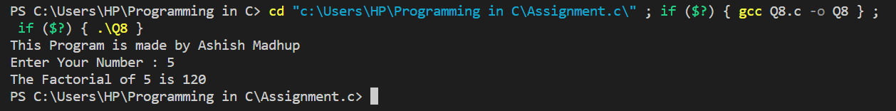

# //        Q9.  WAP TO CHECK WHETHER THE NUMBER IS ARMSTRONG // OR NOT

#include<stdio.h>

int main(){

    printf("This Program is made by Ashish Madhup \n");

    int n,a,r,sum=0;

    printf("Enter Your Number :");

    scanf("%d",&n);

    a=n;

    while(n!=0)

    {

        r=n%10;

        sum=r*r*r + sum;

        n=n/10;

    }

    if(sum==a)

    {

        printf("%d is an Armstrong Number ",a);

    }

    else

    {

        printf("%d is not an Armstrong Number ",a);

    }

return 0;

}

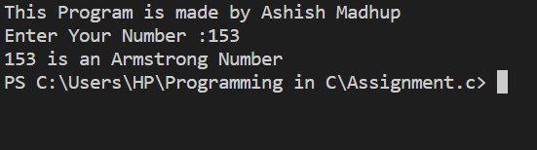

# //      Q10.    WAP TO CHECK WHETHER THE NUMBER IS PALINDROME // OR NOT.

#include<stdio.h>

int main(){

    printf("This Program is made by Ashish Madhup \n");

    int n,a,r,s=0;

    printf("Enrter Your Number : ");

    scanf("%d",&n);

    a=n;

    while(n>0)

    {

    r=n%10;

    s=r+s*10;

    n=n/10;

    }

    if(a==s)

    {

    printf("%d is a Palindrome Number",a);

    }

    else

    {

    printf("%d is not a Palindrome Number",a);

    }

return 0;

}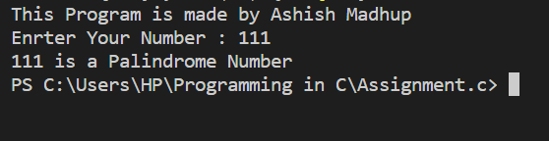

# //          Q11. WAP TO FIND THE REVERSE OF A NUMBER.

#include<stdio.h>

int main(){

    printf("This Program is made by Ashish Madhup \n");

    int n, r,s=0;

    printf("Enter an integer: ");

    scanf("%d", &n);

    while (n != 0)

    {

    r = n % 10;

    s = s * 10 + r;

    n =n / 10;

    }

    printf("Reversed number = %d", s);

return 0;

}

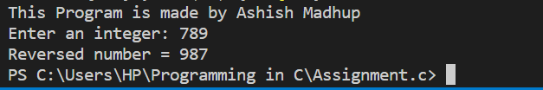

# //           Q12.   WAP TO CHECK WHETHER THE GIVEN NUMBER IS EVEN // OR ODD.

#include<stdio.h>

int main(){

    printf("This Program is made by Ashish Madhup \n");

    int num;

    printf("Enter an integer: ");

    scanf("%d", &num);

    if(num % 2 == 0)

        printf("%d is even.", num);

    else

        printf("%d is odd.", num);

    return 0;

}

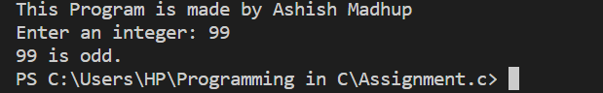

# //     Q13.      WAP TO CHECK WHETHER THE GIVEN NUMBER IS PRIME // OR NOT

#include<stdio.h>

int main() {

    printf("This Program is made by Ashish Madhup \n");

    int n, i, s = 0;

    printf("Enter any number :");

    scanf("%d", &n);

    for (i = 1; i <= n; i++) {

    if (n % i == 0) {

        s++;

    }

    }

    if (s == 2)

    {

        printf("%d is a Prime number",n);

    }

    else

    {

    printf("%d is not a Prime number",n);

    }

return 0;

}

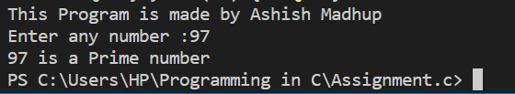

//       Q14.    WAP TO FIND THE LARGEST OF THREE NUMBERS TAKEN // INPUT BY THE USER

#include<stdio.h>

int main(){

    printf("This Program is made by Ashish Madhup \n");

    double n1,n2,n3;

    printf("Enter three different numbers: ");

    scanf("%lf %lf %lf", &n1, &n2, &n3);

    if (n1 >= n2 && n1 >= n3)

    printf("%.2f is the largest number.", n1);

    if (n2 >= n1 && n2 >= n3)

    printf("%.2f is the largest number.", n2);

    if (n3 >= n1 && n3 >= n2)

    printf("%.2f is the largest number.", n3);

return 0;

}

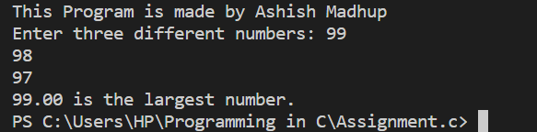

# //         Q15.   WAP TO PRINT A MULTIPLICATION TABLE

#include<stdio.h>

int main(){

    printf("This Program is made by Ashish Madhup \n");

    int n;

    printf("Enter a Number : ");

    scanf("%d",&n);

    for(int i=1;i<=10;i++)

    {

        printf("%d * %d = %d\n",n,i,n*i);

    }

return 0;

}

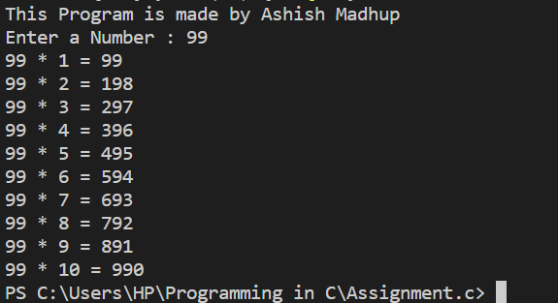

# //            Q16.      WAP TO PRINT FIBONACCI SERIES

#include<stdio.h>

int main(){

    printf("This Program is made by Ashish Madhup \n");

int first=0, second=1, i, n, sum=0;

printf("Enter the number of terms: ");

scanf("%d",&n);

printf("Fibonacci Series:");

for(i=0 ; i<n ; i++)

{

if(i <= 1)

{

sum=i;

}

else

{

sum=first + second;

first=second;

second=sum;

}

printf(" %d",sum);

}

return 0;

}

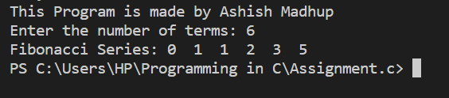

# //      Q17.        WAP TO INSERT ELEMENTS INTO AN ARRAY AND PRINT // THE ARRAY ELEMENTS

#include<stdio.h>

#include<conio.h>

int main()

{

    printf("This Program is made by Ashish Madhup \n");

    int arr[10], i, element;

    printf("Enter 5 Array Elements: ");

    for(i=0; i<5; i++)

        scanf("%d", &arr[i]);

    printf("\nEnter Element to Insert: ");

    scanf("%d", &element);

    arr[i] = element;

    printf("\nThe New Array is:\n");

    for(i=0; i<6; i++)

        printf("%d  ", arr[i]);

    getch();

    return 0;

}

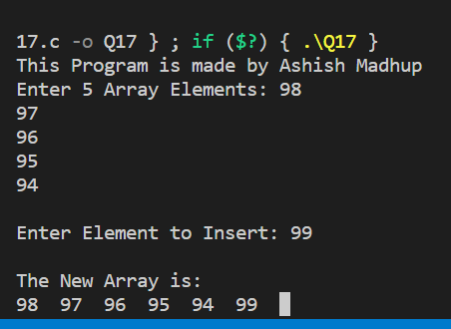

# //         Q18.     WAP TO CREATE 3X3 MATRIX AND PRINT ITS ELEMENTS

#include<stdio.h>

int main(){

    printf("This Program is made by Ashish Madhup \n");

int a[3][3];

int i,j;

printf("Enter the values of first matrix::\n");

for(i=0;i<3;i++)

{

for(j=0;j<3;j++)

{

printf("Matrix [%d][%d]: ",i,j);

scanf("%d",&a[i][j]);

}

}

printf("Matrix is\n");

for(i=0;i<3;i++)

{

for(j=0;j<3;j++)

{

printf("%d",a[i][j]);

}

printf("\n");

}

return 0;

}

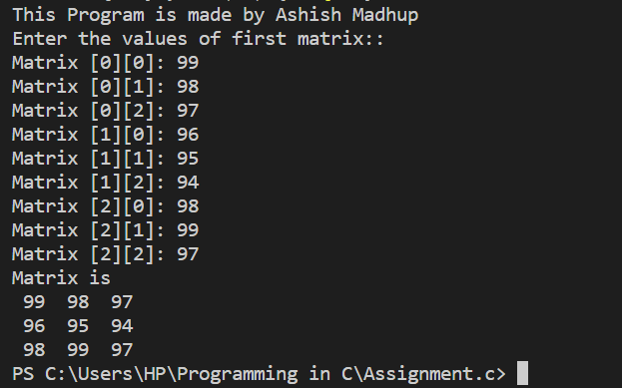

# //   Q19.       WAP TO CALCULATE THE LENGTH OF THE STRING

#include <stdio.h>

int main() {

    printf("This Program is made by Ashish Madhup \n");

    char s[] = "Ashish Madhup is Champian";

    int i;

    for (i = 0; s[i] != '\0'; ++i);

    printf("Length of the string: %d", i);

    return 0;

}

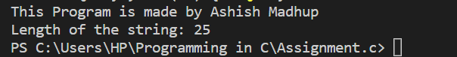

# //                   Q20.   WAP TO PRINT THE REVERSE OF A STRING.

#include<stdio.h>

#include<string.h>

int main()

{

    printf("This Program is made by Ashish Madhup \n");

    char str[20];

    printf("Enter the String to get reversed\n");

    gets(str);

    printf("Reversed string = %s",strrev(str));

return 0;

}

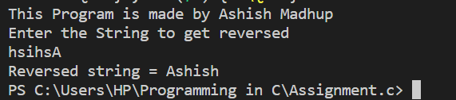

# //       Q21.   WAP TO CALCULATE THE AREA OF A SUARE USING A // FUNCTION.

#include<stdio.h>

void squ_area(int a)

{

    int area;

    area=a*a;

    printf("Area of Square is %d:",area);

}

int main(){

    printf("This Program is made by Ashish Madhup\n");

    int s;

    printf("Enter of Side of Square is :");

    scanf("%d",&s);

    squ_area(s);

return 0;

}

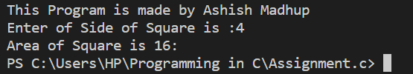

# //          Q22.    WAP TO SWAP THE TWO VARIABLES USING CALL BY

# // VALUE

    #include <stdio.h>

void swap(int , int);

int main()

{

    printf("This Program is made by Ashish Madhup \n");

    int a = 10;

    int b = 20;

    printf("Before swapping the values in main a = %d, b = %d\n",a,b);

    swap(a,b);

    printf("After swapping values in main a = %d, b = %d\n",a,b);

}

void swap (int a, int b)

{

    int temp;

    temp = a;

    a=b;

    b=temp;

    printf("After swapping values in function a = %d, b = %d\n",a,b);

}

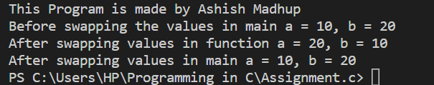

# //      Q23.    WAP TO SWAP THE TWO VARIABLES USING CALL BY // REFRENCE

    #include <stdio.h>

void swap(int*, int*);

int main()

{

    printf("This Program is made by Ashish Madhup \n");

   int x, y;

   printf("Enter the value of x and y\n");

   scanf("%d%d",&x,&y);

   printf("Before Swapping\nx = %d\ny = %d\n", x, y);

   swap(&x, &y);

   printf("After Swapping\nx = %d\ny = %d\n", x, y);

   return 0;

}

void swap(int *a, int *b)

{

   int temp;

   temp = *b;

   *b = *a;

   *a = temp;

}

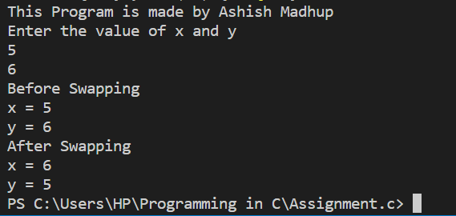

# //    Q24.      WAP TO SHOW ADDITION OF TWO NUMBERS USING // POINTERS

    #include <stdio.h>

int main()

{

    printf("This Program is made by Ashish Madhup \n");

    int first, second, *p, *q, sum;

    printf("Enter two integers to add\n");

    scanf("%d%d", &first, &second);

    p = &first;

    q = &second;

    sum = *p + *q;

    printf("Sum of entered numbers = %d\n",sum);

    return 0;

}

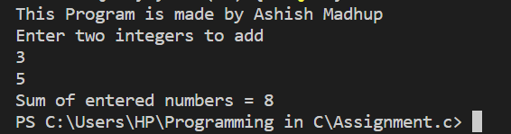

//        Q25.    WAP TO STORE THE STUDENT NAME AND AGE INTO THE STRUCTURES AND

//              ACCESS STRUCTURE DATA MEMBERS TO DISPLAY THESE VALUES AS AN OUTPUT

    #include <stdio.h>

struct student {

    char firstName[50];

    int roll;

    float marks;

} s[5];

int main() {

    printf("This Program is made by Ashish Madhup \n");

    int i;

    printf("Enter information of students:\n");

    for (i = 0; i < 5; ++i) {

        s[i].roll = i + 1;

        printf("\nFor roll number%d,\n", s[i].roll);

        printf("Enter first name: ");

        scanf("%s", s[i].firstName);

        printf("Enter marks: ");

        scanf("%f", &s[i].marks);

    }

    printf("Displaying Information:\n\n");

    for (i = 0; i < 5; ++i) {

        printf("\nRoll number: %d\n", i + 1);

        printf("First name: ");

        puts(s[i].firstName);

        printf("Marks: %.1f", s[i].marks);

        printf("\n");

    }

    return 0;

}

